# [COSC2673](https://rmit.instructure.com/courses/79534) Machine Learning

# Assignment 2: Machine Learning Project

# 

|  |  |  |  |  |  |
| --- | --- | --- | --- | --- | --- |
| |  | | --- | | **Student Name** | | |  | | --- | | **Student ID** | | |  | | --- | | **Email ID** | |
| |  | | --- | | Aparupa Mitra | | |  | | --- | | s3831724 | | |  | | --- | | s3831724@student.rmit.edu.au | |

**Aim of Project:** Classify Images of Colon Cancer where we need to perform two tasks:

1.Classify images according to whether given cell image represents a cancerous cell or not.

2.Classify images according to cell-type, such as: fibroblast, inflammatory, epithelial or others.

**1.Approach**:

We have developed two model, one model for predicting whether a patient is having cancer or not. Second model is for classifying cell types. Both models have been described as below. Our approach was to find the best model which give the high accuracy with low loss and with minimum overfitting.

**Task 1 Model**: We have merged both dataset data_labels_mainData.csv and data_labels_extraData.csv and used combined data and used for this model. Here model classifies images according to whether given cell image represents a cancerous cell or not. We have used convolutional neural network, a type of neural network algorithm which each unit in layer is connected to previous layer through convolutions kernel that is output of each unit in a layer is a convolution of kernel over the image input.

We created first baseline model which consists of three VGG blocks each block consists of two layers of convolution layer and Max pooling layer. This was followed by developing two more model one with regularizing and hyperparameter tuning by introducing lambda value =0.001 and a Dropout of 20% and last one with Augmented images. Best model out of all three models gave us least overfitting and helped to predict a patient cancerous or not. We have saved its weight for future use.

**Task 2 Model**: Our second model was developed to classify cancerous cell types - fibroblast, inflammatory, epithelial or others. Here also we have developed another convolutional neural network model with three VGG blocks each block consists of two layers of convolution layer and Max pooling layer. Here we have created three model (baseline, regularized and augmented with lambda value =0.001 and a Dropout =0.20). The best model gave a good accuracy compared to others and can be used to classify cell types.

**How to use unlabelled data provided in data_labels_extraData.csv in Model 2, cell type classification?**

Once we found best model capable of predicting is cancerous or not, we saved its weight by calling ModelCheckpoint () callback. These weights will be used in second model classifying cell types. So here we have used the concept of Transfer learning [2],[3] which is a machine learning method where a model developed for a task is reused as the starting point for a model on a second task.

In our best model (cell type model), we have loaded the weights from first model (iscancerous model) and transferred it from to our task 2 cell type best model. Since there is shape difference while transfer the pretrained model weight, as Model1(best model of task1) has shape (,2) and Model2 (best model of task2) has shape (,4), so we have used get_weights() in each layer and transfer to the new layers with set_weights(weights). Finally, we again evaluated our weighted model for classifying cell types.

**2.Independent Evaluation of model** **(Compare and contrast your results to other research works.):**

We have gone through a research paper in research gate [1] related to Deep Learning with Sampling in Colon Cancer Histology and tried to compare with our project.

1. **Model architecture comparison:**

According to research paper [1], the algorithm comprised two convolutional neural networks (CNNs) working in series. The ﬁrst network was a detection network which located cells and passed the cell coordinates to the second network, which is a classiﬁcation network which categorized each cell as epithelial, inﬂammatory, a ﬁbroblast and “other.”

Our model comprises of three VGG blocks of network. Each block consists of two layers of convolution layer and Max pooling layer. Finally, images are flattened and passed through Dense layer which determines cell type.

According to research paper [1], training dataset was an augmented and consist of a set of RGB images of size [500 ×500] at 20X. The output of the algorithm was a cell map—a set of cell locations and cell types.

Our data set consist of 27x27 RGB images of colon cells from 99 different patients. The output of algorithm was any of four cell types- fibroblast, inflammatory, epithelial or others.

1. **Classification algorithm comparison:**

According to research paper [1], random sampling was carried out which samples patches with uniform weighting. The cell detection algorithm applied to each patch individually. The classiﬁcation module extracted small patches around each detected point, normalized them collectively, and applied the CNN classiﬁcation algorithm to each patch individually.

In our model, we have used ImageDataGenerator to perform data transformation on the images. Through ImageDataGenerator class one can apply any kind of transformations on images as it is passed to the model. This was applied on entire data that was divided into train, validation and test. The batches of images are then passed into CNN model.

1. **Result Comparison:**

From research paper [1] detection accuracy was 65% classification accuracy for cell type shows average of 76%.

Our model (best of all 3 model for cell type classification) gave test accuracy about 70 %. And train accuracy of 75%.

**3.Comparison between two Models**

Our first model predicts images cancerous or not. We have built baseline line model which sows overfitting [Appendix 1]. So, we build regularized model followed by model from augmented data images. Final Model gave very good test accuracy of about 87% and train of about 88% reducing overfitting [Appendix 2].

Second Model classifies images based on cell types. Here too we created baseline model which shows overfitting [Appendix 3]. Then data augmented model with regularized and hyperparameter tuning within that gave reduced overfitting and gave test accuracy of about 70% and train accuracy of around 75% [Appendix 4].

**4. Ultimate judgement**

Looking at both model we saw our first task model that predicts cancerous or not provides a very good performance in terms of prediction. Although cell type classification model also gave a good prediction percentage.

However, we saw that applying transfer learning, that is using weights from pretrained model (Task 1 model) into cell type classification model (Task 2 model) does not gave a very good performance. But we still feel that this concept will be helpful for using any future unlabelled dataset in cell type classification model.

**Bibliography:**

1. 2021. [online] Available at: <https://www.researchgate.net/publication/332016384_Deep_Learning_With_Sampling_in_Colon_Cancer_Histology> [Accessed 26 May 2021].
2. TensorFlow. 2021. *Transfer learning and fine-tuning  |  TensorFlow Core*. [online] Available at: <https://www.tensorflow.org/tutorials/images/transfer_learning> [Accessed 27 May 2021].
3. TensorFlow. 2021. *Save and load models  |  TensorFlow Core*. [online] Available at: <https://www.tensorflow.org/tutorials/keras/save_and_load#manually_save_weights> [Accessed 23 May 2021].

**Appendix:**

**1.** **Task 1 (Iscancerous detection) ,Baseline Model (Overfitting)**

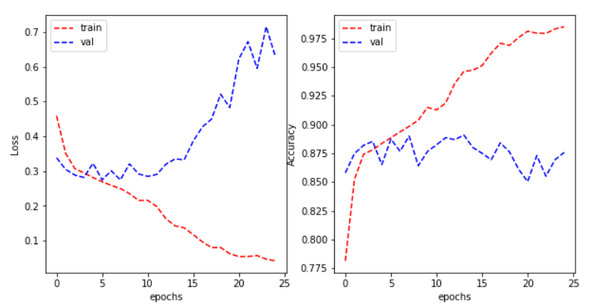

**2. Task 1 (Iscancerous detection), Data Augmented model**

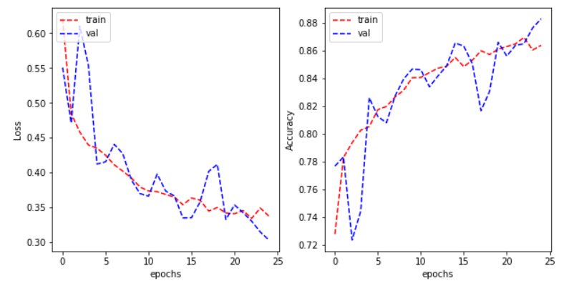

1. **Task 2 (cell type classification), Baseline model (Overfitting)**

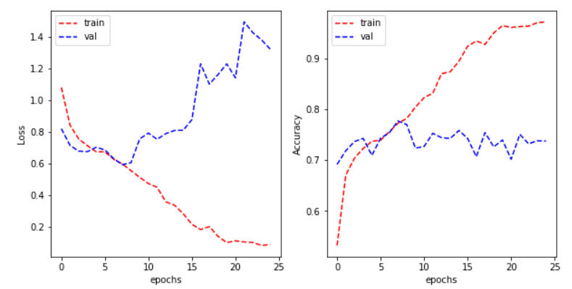

1. **Task 2 (cell type detection), Data Augmented model**

